Step 1. Left Click to Open Your Wireless Connections. This will show a list of available Wireless Networks
Step 2. Highlight the AuroraUniversityOC Wireless Network and Click Connect
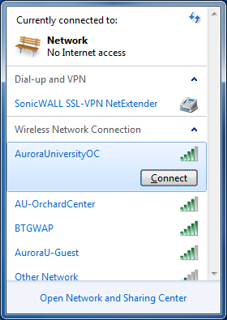
Step 3. When prompted for the Security Key, enter 2245Orchard (alpha-numeric and Case-sensitive), click OK
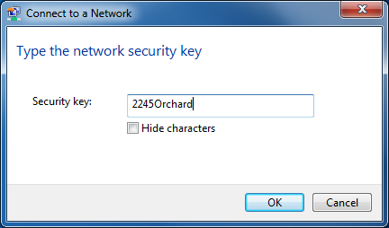
Step 4. Open a Web Browser, or Web Page and you will see the Secure Internet Portal Page. Click Accept to agree to the Acceptable Use Policy (You must Click Accept to successfully login to the Wireless Network)
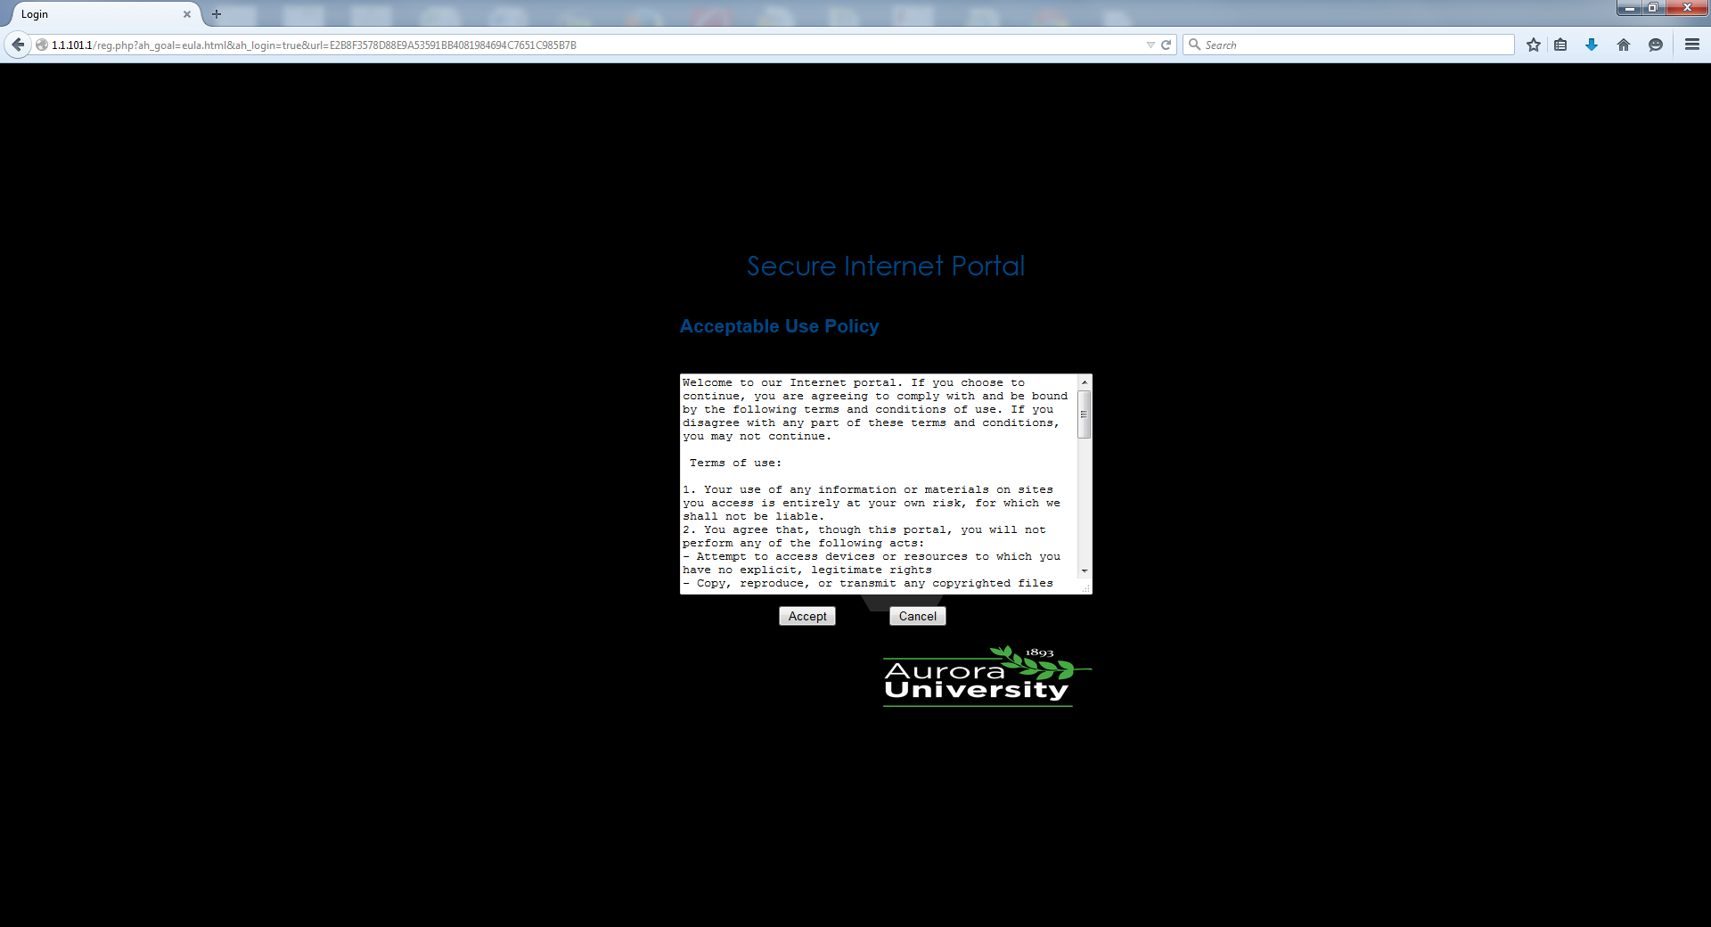
When you have successfully logged in, you will see the following page.
